# Assignment on Jenkins job creation
-Anushka Gaikwad

- Iaunched machine and installed java-17 on it
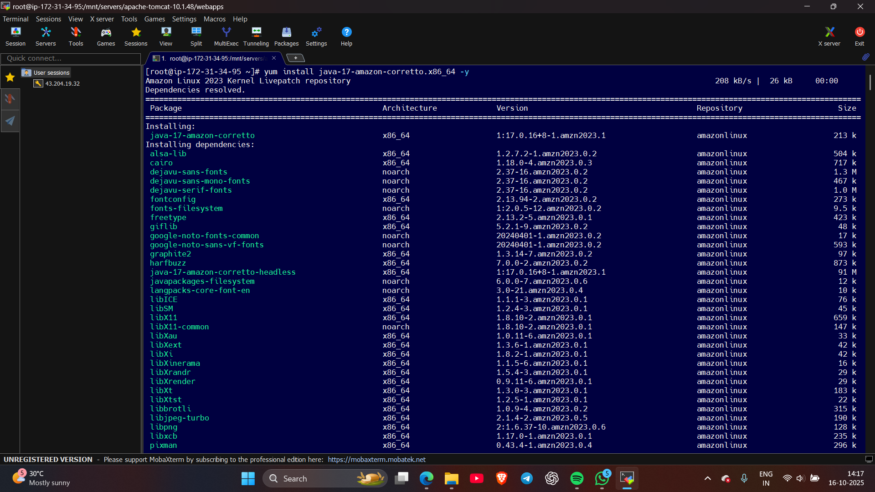
- Installed tomcat server on folder server
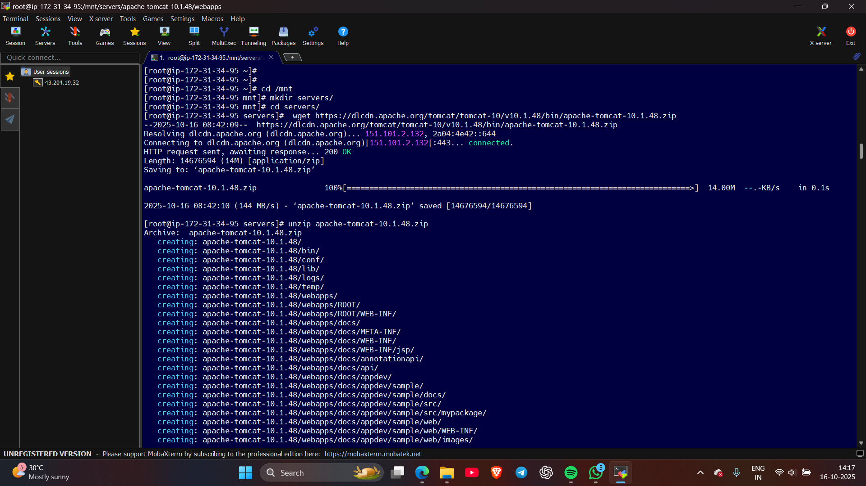
- Started tomcat server by ./startup.sh
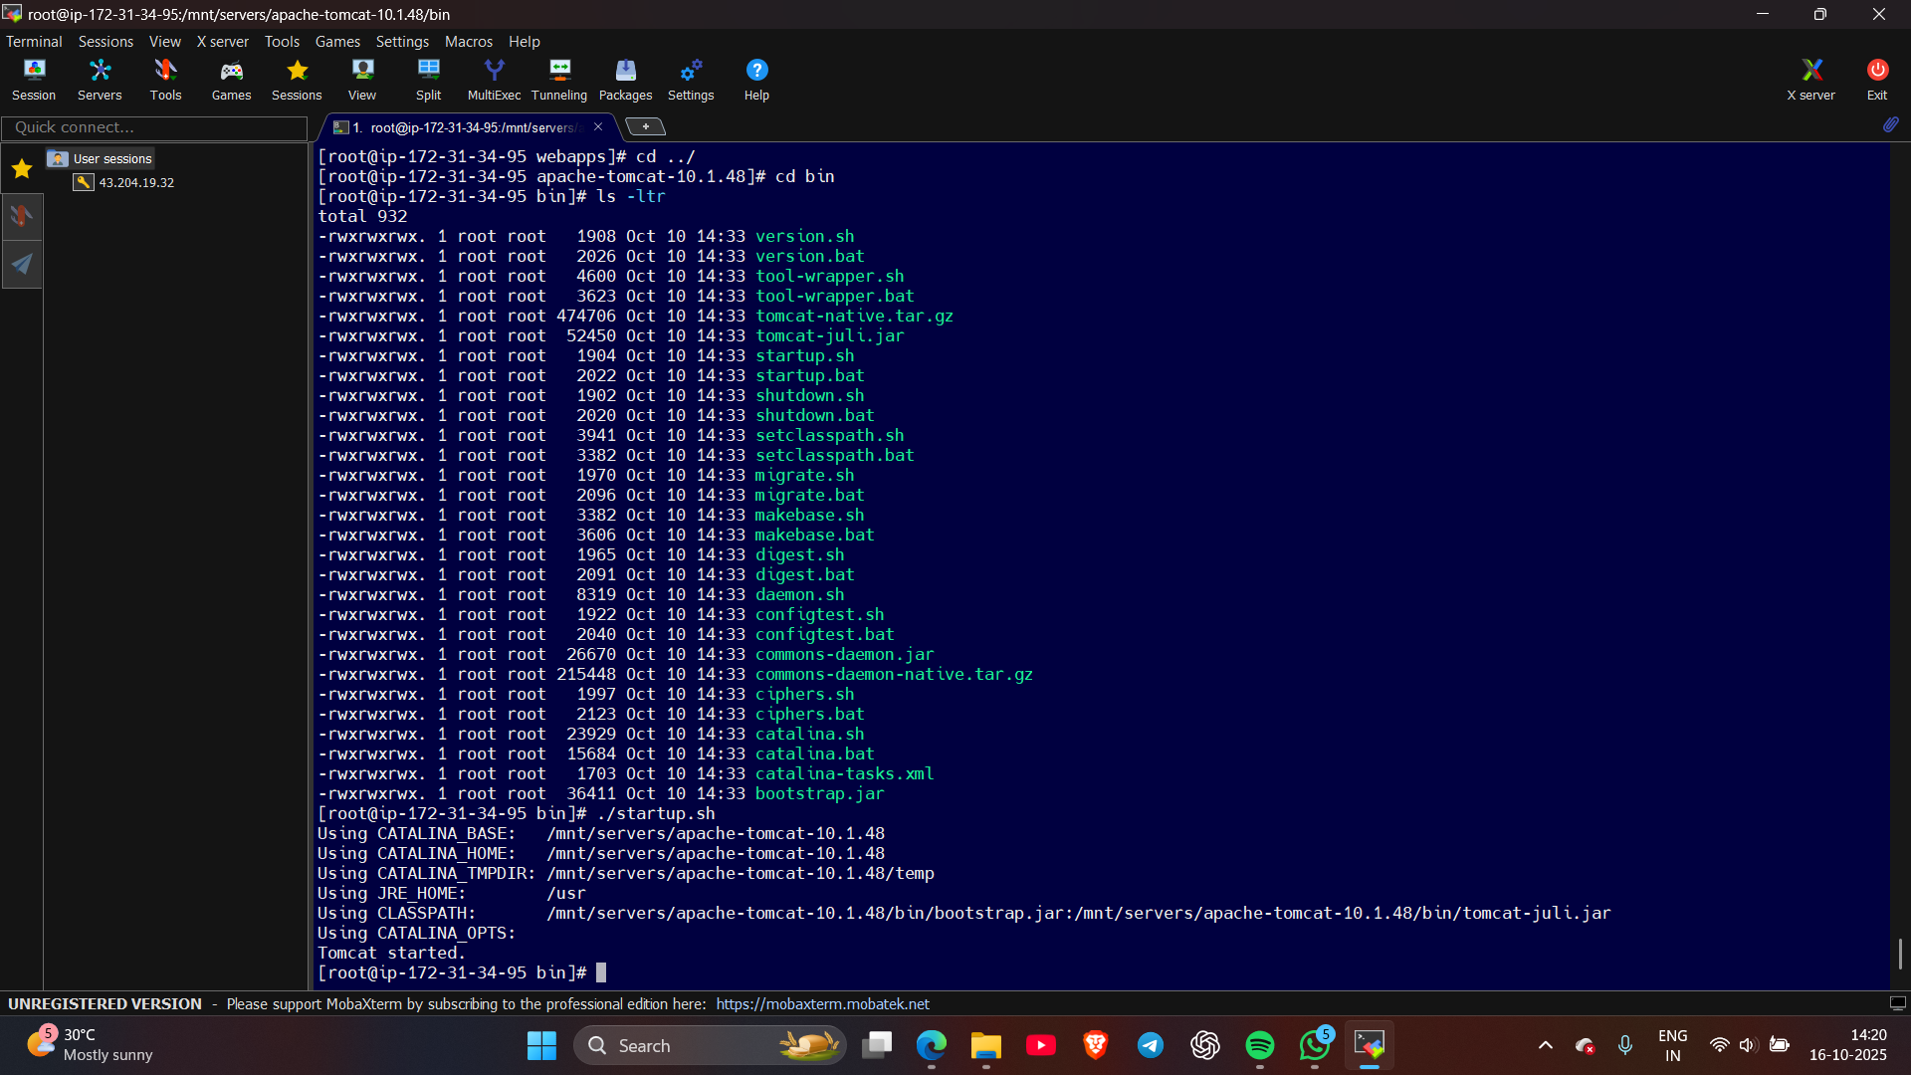
- Logged in into Jenkins dashboard
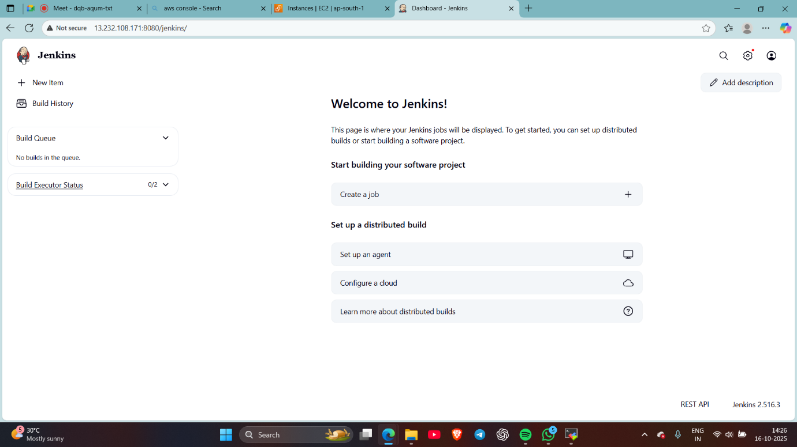

- Creating a freestyle job
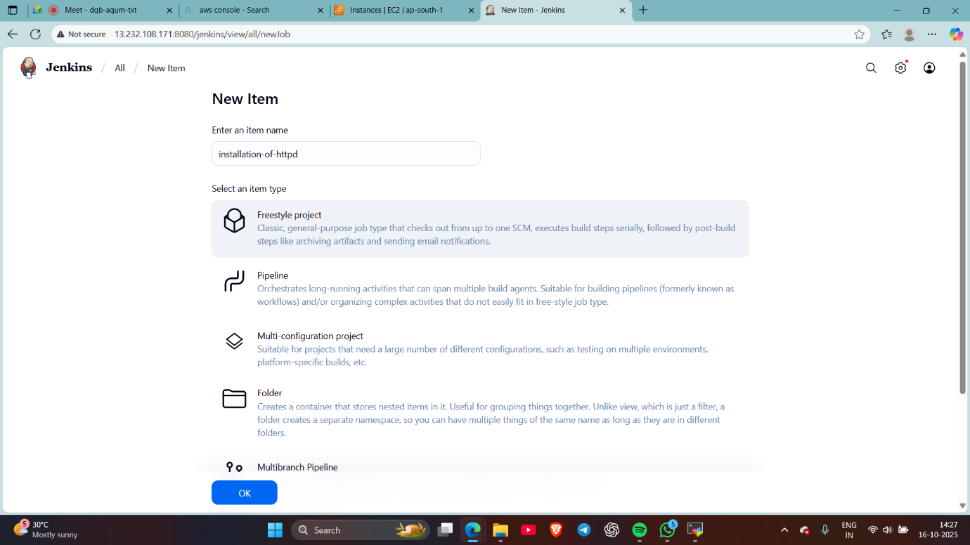
- Written a script to install httpd, start it, and to make a index.html page
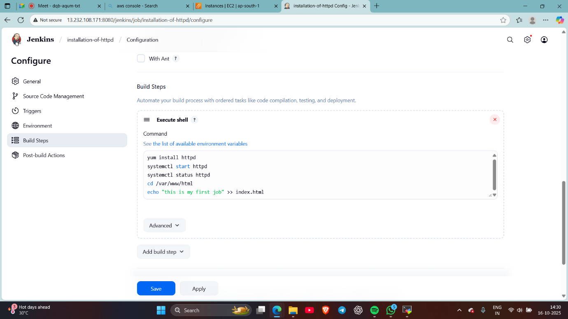
Job created

- Build a job
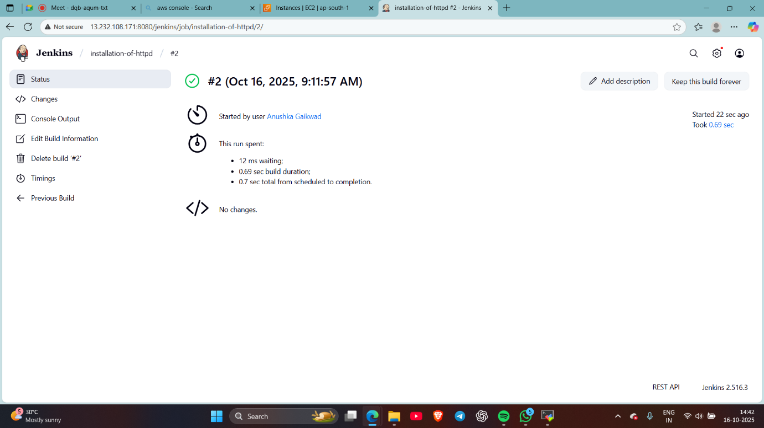
- Checked whether job is done or not
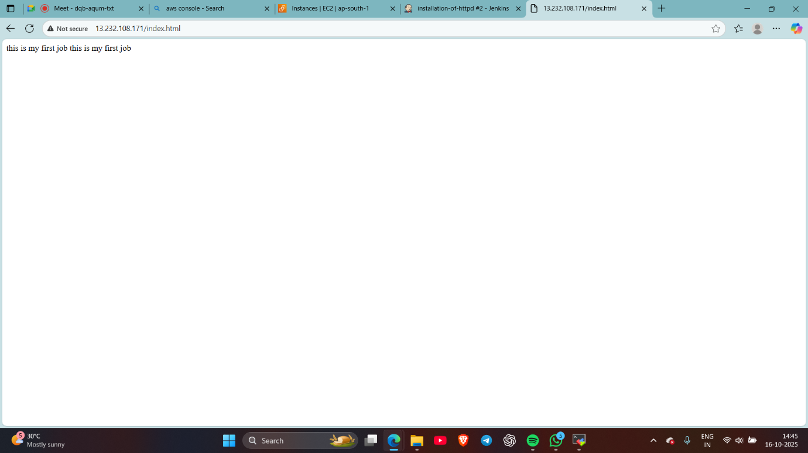
done

